Tue 7/14/2020 11:24 AM

So these are the “reputable health and safety resources” according to the attached document:

**REQUIREMENTS & RESOURCE:**

Decision-making must use reputable health and safety resources. Examples are:

• World Health Organization <https://www.who.int/>

• US Centers for Disease Control <https://www.cdc.gov/>

Here’s a link to a quick video of leaders from these organization (in additional to our own Surgeon General) that I’d like you guys to watch:

<https://twitter.com/delbigtree/status/1279153796661338112>

This was what we were told a few months back, but now all of a sudden we’re expected to just blindly follow and do the exact opposite… because they said we should? Why should *[Employer or Organization Name]* be basing policy on organizations that clearly can’t make their mind up? Are masks good for us, or are they not?

**From:** [Employer or Organization Name]   
**Sent:** Tuesday, July 14, 2020 8:01 AM  
**To:** [All Employees]  
**Subject:** [EMPLOYER OR ORGANIZATION NAME] COVID-19 UPDATE

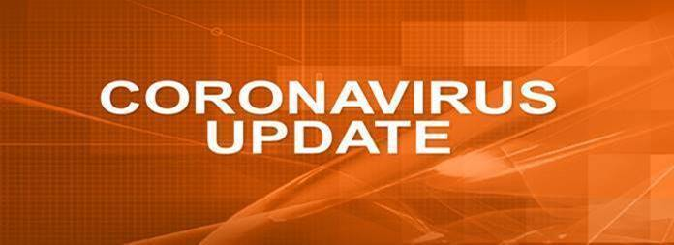

  ************************************************

**Managers are REQUIRED to share this message with employees who do not have email access.**

************************************************

**[EMPLOYER OR ORGANIZATION NAME] COVID-19 UPDATE**

**July 14, 2020**

To All Employees:

We have updated the [EMPLOYER OR ORGANIZATION NAME] COVID-19 Guidelines. Please review the attached guidelines to ensure that you are following the most recent [EMPLOYER OR ORGANIZATION NAME] COVID instructions and reporting responsibilities.

We have received a lot of feedback and observations of employees not properly wearing their mask. Masks and face shields are only effective only if they are worn properly. When wearing your mask please make sure that the mask fits snugly and covers the mouth and nose up to the nose bridge and chin. The same applies for face shields, ensure your nose, mouth and chin are covered.  Properly wearing your mask/face shield protects you and others around you from potential exposure.

**Right way to wear a mask                                                            Wrong way to wear a mask**

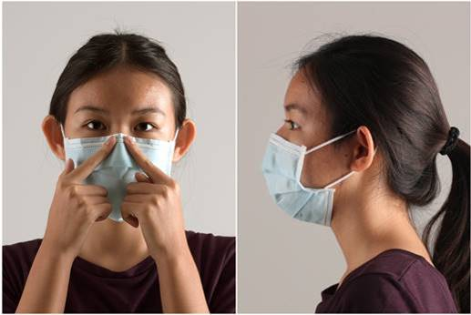         

Employees are asked to continue following the [EMPLOYER OR ORGANIZATION NAME] safety guidelines, which includes wearing masks, maintaining social distance, washing your hands, and disinfecting your areas. We will continue communicating our action plans towards safeguarding your health. These precautions help maintain the safety of all employees and their families!