Thu 2/18/2021 11:29 AM

No need to push this up the chain. I agree with your 2 points below. There’s nothing we can say or do to get them to follow the actual data instead of the contradictory guidelines coming straight from the CDC, SCDHEC, etc. It’s almost like these government run agencies are behaving like a leg of the pharmaceutical industry in order to promote the rollout of a new product to the entire population, or something like that.

**From:** [Manager Name]   
**Sent:** Thursday, February 18, 2021 8:42 AM  
**To:** Jeffcoat, Brent S.  
**Subject:** RE: Random COVID Testing Update

The message struck me as odd too as we’ve seen a very significant decrease in the last couple of weeks.  Honestly, I think it’s a couple of things at play.

1. They needed to send out a message saying the process (really just location at which someone is identified for random testing) is changing.
2. There seems to be a lack of real effort to develop the communication prior to sending it out.  I don’t know if this is a cut/paste bits and pieces job or what, but the first sentence isn’t even a sentence.

You started off your note saying you were venting.  We’re you really just looking to vent, or do you want me to push this up the chain?  You know I’m game either way.

Thanks and I feel ya.

*[Manager Name]*

**From:** Jeffcoat, Brent S.  
**Sent:** Wednesday, February 17, 2021 5:35 PM  
**To:** [Manager Name]  
**Subject:** FW: Random COVID Testing Update

Another vent *[Manager Name]*… sorry. I just can’t help it when I see some of these communications. I guess they have really become, as they say, a “trigger” for me these days, lol.

What data source are we following to be able to definitively make the statement that cases continue to rise? According to SCDHEC, there were only 655 new cases State-wide as of Feb 15, which is **down nearly 90%** from the 6,139 cases recorded on Jan 8. I’d say that constitutes a downward trend…

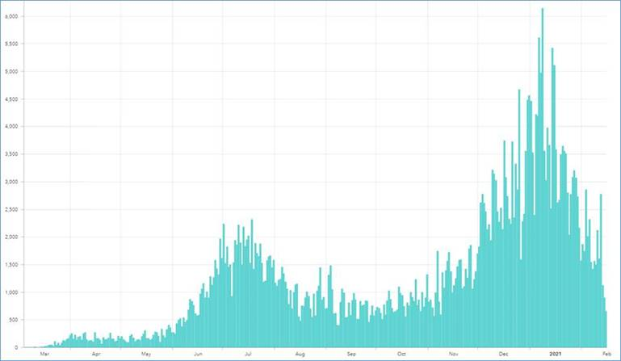

655 cases on Feb 15

6,139 cases on Jan 8

Source: SCDHEC.org

Even Deaths are trending down significantly as well, which is all great news!

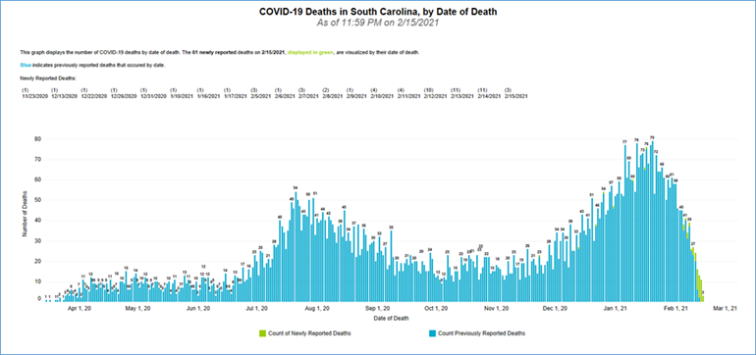

Source: SCDHEC.org

So what’s the logic for pushing for more random testing? Are we trying to contribute to some push for another upward trend in cases by increasing the volume of healthy individuals being tested? I’d like to know who’s calling these shots, because it would appear that they are incredibly misinformed. These important decisions should be driven by data (not the media), and someone with the capability of accessing, reviewing, and interpreting the actual data (and trends) should be contributing to our decision making within *[Company or Organization Name]*. The data presented here (along with county level data) is readily available on SCDHEC’s website (very comprehensive), and it only took me a few seconds to copy and paste it here. Where’s the ‘questioning attitude’ that we preach on a regular basis? I just don’t know how you could be aware of the data above and still make the comments below. I have to assume that our decision makers have not been following this type of data, and I don’t know the best way to bring it to their attention.

Thanks,

Brent

**From:** [Company or Organization Name]   
**Sent:** Wednesday, February 17, 2021 2:34 PM  
**To:** [All Employees]  
**Subject:** Random COVID Testing Update

**Managers are asked to share this message with employees who do not have email access.**

To all employees,

As COVID cases continue to rise locally, statewide, and across the country. We ask that employees take extra precautions during these times to protect yourself and your family by wearing masks, maintaining social distance, and practicing proper hygiene while on and off-duty to minimize exposure.

*[Company or Organization Name]* will continue our random on-site COVID-19 testing. Previously, employees were notified by security as you arrived at main gate that you were selected for testing. Effective immediately, you will now be notified by security as you enter the facility.

Testing will still be conducted for the 3rd shift/nightshift as you are leaving, 1st shift/dayshift and  2nd shift  as you are arriving.

Once you have completed the test, you will be given a paper showing you have completed the test. You will need to provide the completed paperwork to Security when you badge into the facility or arrive back on-site for your next shift.

The COVID test takes approximately two minutes.  Please allow yourself enough time for testing.