Dear Lexington County School District One Board of Trustees and Superintendent,
Included herein is dialogue for the speech presented at today’s school board meeting, along with further discussion points and an abundance of references.
Dialogue for Presentation at Lexington School District One Board Meeting on May 4, 2021:
Intro: My name is Brent Jeffcoat, I am: an Inventor & Small Business Co-Owner (Patent Holder), a Principal Engineer specialized in RDT&E in the Nuclear Power Industry, a Coach (Lacrosse & Softball), a Loving Husband & Father, and a Child of God (Priorities are in reverse order).
Credentials and References: Credentials are great and should be celebrated, but if you’re going to stand on your credentials then it should be easy to provide supporting evidence for your argument. After all, unbiased evaluation of the evidence IS “Science”, and the “Science” is NOT settled in regards to masks as most of the “Experts” that we look to for guidance (i.e. CDC, SCDHEC, Dr. Jane Kelly) would have us believe. We’re all human, and we’re all fallible. That said, I will not stand up here and tell you that “I can point to study, after study, after study” without providing references. I have provided them (along with some further discussion points) in the form of a letter/handout.
Perception vs. Reality: Do you believe that cloth stops viruses? You have every right to believe this. If you truly believe that cloth stops viruses, then YOUR mask will protect you and YOUR children… and I can exercise MY right to decide for MY children. As a society, we so desperately desire for interventions (masks) to save us that we’ve WILLED them to work. It’s an illusion of control, and it’s the placebo effect in action.
Asymptomatic Spread: In your video interview of Dr. Kelly, the Hair Stylist Example comes up once again. It’s anecdotal, not a published study, and it relies on asymptomatic spread. Good studies rely on Randomized Control Trials (RCTs), and the CDC is on record as stating that they “are not aware of any randomized control trials that show that masks or double masks or cloth face coverings are effective against COVID-19” (yes, I have a reference). Dr. Anthony Fauci himself is on record as stating that “an epidemic is not driven by asymptomatic carriers”, that “people should not be walking around with masks”, that masks are “not providing the perfect protection that people think”, and that “often there are unintended consequences” of wearing them. If you believe the “Science” has changed over the past year, then you are part of the problem! Our perceptions of Risk and Safety are the only variables that have changed.
Risk: The Child Population of SC is approx. 1,135,778. Only 2-8 child COVID-19 Deaths have been reported as of April 30, 2021 (Note: this number is suppressed by SCDHEC. Why?). That’s a 1 in 142,000-568,000 risk of child death from COVID-19 in SC. By comparison, SC had 3 Deaths associated with Flu (under age 18) in the 2018 Season, which is a 1 in 379,000 risk of child death from Flu. Conclusion, these risks are COMPARABLE and NEGLIGIBLE! In your interview, Dr. Kelly makes a comparison of masks to seatbelts. This is not a valid comparison, BUT just for the sake of argument, let’s make the comparison. There’s a 1 in 55,000 risk of child death from Motor-Vehicle Accidents in the US. This risk is FAR GREATER by a full order of magnitude than COVID-19 for our children! Is that a fair comparison?
Collateral Damage: I don’t have time to discuss everything I want to here, but I would encourage you to look into the information that I’ve researched and provided regarding the Psychology of Conformity, Excess Deaths, and Life Years Lost. We have undoubtedly created a man-made secondary pandemic through our overreaction and overreach. I’d like to point out, I have on good faith that we had a 15 fold increase in child suicides in Lexington County in 2020… let that sink in for just a moment. Ages 9-15. These are Deaths of Despair, and Yes, I firmly believe facemasks do contribute to the hysteria that drives them.
Closing Remarks: Many would say that the information I’m sharing with you today is dangerous. I would say it’s dangerous to ignore this information! We’re not asking you to eliminate masks, we’re imploring that you make them optional! Let us exercise our right as parents to decide what’s in the best interest of our children. Our children are not at risk of contracting or spreading this virus, and they do NOT deserve to bear the burden resulting from our hysteria. I firmly believe that the measures that we’ve implemented out of an abundance of overreaction and overreach, along with the tragedy resulting from our collective FEAR and Illusion of Control, WILL be revealed in time to be criminal in nature. Where will YOU be standing when that time comes? It’s time to change course. Make Masks Optional!
Further Discussion:
You posted a 22 minute video (https://www.youtube.com/watch?v=dRDLaGERh5Q) featuring Dr. Jane Kelly (SCDHEC Assistant State Epidemiologist), which is chock full of propaganda and conjecture, on May 3, 2021, just 1 day ahead of this meeting. You knew many parents were coming to speak at today’s board meeting about making masks optional for children in our school district, and it feels like you did this so that we wouldn’t have any time to prepare a response. This felt deliberate and underhanded, but you didn’t account for the fact that many of us have been preparing for this moment for the better part of a full year now. Short notice aside, below you will find several key points of discussion (with references included) based on the video interview of Dr. Jane Kelly that you published on May 3, 2021.
Credentials – Dr. Jane Kelly is an Epidemiologist, and that’s quite the accomplishment even if it is specialized in HIV and not respiratory viruses. However, she is NOT an Industrial Hygienist, which means she is no more of an expert on facemasks than anyone here in this room, unless you are an Industrial Hygienist (show of hands???). I’d like to point out that she is even discounting our own Governor. I myself am a Principal Engineer specializing in Research Development Testing & Evaluation in the Nuclear Power Industry. I’m a Small Business Owner, Inventor, and soon to be Patent Holder. And most importantly, I am the Father of two Children in your school district, which makes me as qualified as anyone to speak on the behalf of their health and wellbeing!
References – Dr. Jane Kelly provided zero. She explicitly states that she can show “study after study after study that demonstrate the efficacy…of wearing masks” I’d like to request the references, and I’d like to provide you with a list of my own (see References to Randomized Control Trial (RCT) Efficacy Studies below) that demonstrate the opposite. The key is to look for Randomized Control Trials (RCTs), especially those for cloth masks and public settings, although not many exist. The CDC is even admits that they “are not aware of any randomized control trials that show that masks or double masks or cloth face coverings are effective against COVID-19” (see Reference to Statement from the CDC Regarding RCT Studies below). The bottom line is that this is NOT a “Science” that is settled!
Multi-Inflammatory Syndrome (MIS-C) – is mostly associated with COVID-19, and only 50-99 total cases have been reported in SC since May 2020. The Child Population of SC is 1,135,778. Only 2-8 child COVID-19 Deaths have been reported as of April 30, 2021 (Note: number suppressed by SCDHEC). That’s a 1 in 142,000-568,000 risk of child death from COVID-19 in SC. By comparison, SC had 3 Deaths associated with Flu (under age 18) in the 2018 Season, which is a 1 in 379,000 risk of child death from Flu. Conclusion, these risks are COMPARABLE and NEGLIGIBLE! (see References for Risks to Children below)
Seatbelts? – Are facemasks like seatbelts? They are both PPE, but that’s where the comparison ends. That doesn’t stop Dr. Jane Kelly from making this comparison. Analogies are NOT examples, as they rely on different data sets for supporting evidence. Seatbelts are specific to automotive accidents, very niche. We’re applying facemasks to all scenarios, one size fits all. Should we take our seatbelts with us when we leave our car? Just for reference and for the sake of comparison, there’s a 1 in 55,000 risk of child death from Motor-Vehicle Accidents in the US. This risk is FAR GREATER than COVID-19 for children! Is that a fair comparison? (see References for Risks to Children below)
China? – Dr. Jane Kelly describes our resistance to facemasks as a cultural challenge. It is true that there are cultural differences across the world, especially between the US and many other nations (most notably the communist Asian nations). Think of how submissive those cultures are and susceptible to being controlled by their governments. Is this really a comparison we should be making, and is it really a path we want to go down? Dr. Jane Kelly even mentions the “reassuring” effect that masks have on people, which leads into the argument of placebo effect. We so wish for facemasks to protect us, that despite all of the conflicting evidence, we convince ourselves that they do.
Droplet Argument – Virus travels in Aerosols. Droplets are much larger in size and actually can be aerosolized when blown through the pores of a mask. This supports the theory that masks actually increase transmission rates instead of slowing them (see References to Hospitalization Rates vs. Stringency (including Mask Mandates) below). Much more research needs to be performed in this area. Again, the “Science” is NOT settled… far from it. There are convincing arguments to be made from either side, and we must encourage debate, not silence it!
Oxygen Deprivation and Other risks – There are studies that show that healthcare workers do end up with headaches after extended periods of use (see References to Randomized Control Trial (RCT) Mask Induced Headache Studies below). Also, we know that babies can and do die from suffocation when they get trapped underneath blankets (cloth). We must not be so naïve as to believe that there are zero physical harms from the extended use of facemasks.
Anxiety Provoking – Dr. Jane Kelly briefly touches on this topic, but it desperately needs more attention. We had 15 Child Suicides in Lexington County in 2020, which is 15 times more than we see in a typical year. These suicides are TRAGIC, far outweigh the physical harm from COVID-19, and I believe them to be a direct result of the FEAR that we allowed to permeate our souls. These innocent children bore the brunt of our panic and overreaction, and we literally scared them to death. Our actions throughout this pandemic will continue to be proven catastrophic once the dust has settled, and we will one day clearly see the collateral damage that we have imposed on ourselves… all for a virus that has an Infection Fatality Rate (IFR) or 0.2 overall, and 0.0 for children! Life Years Lost is a metric that I would encourage everyone to look into, and I have provided my research in this area for your reference. (see Research and References for Life Years Lost, Excess Deaths, and Life Expectancy)
Interpretation of Masks – Dr. Jane Kelly talks about how masks can be interpreted as a protective device, but also as a source of pride. This lends itself to a discussion regarding the Psychology of Conformance, in which there are 3 phases. In one year’s time, many have reached (and acclimated to) the 3rd and final stage of conformity, which is internalization and is akin to adopting or converting to a new religion. Is it possible to reverse this? How do we reverse this? (see Research and References Regarding the Psychology of Conformity)
Who’s really at risk? – Dr. Jane Kelly says that those who do not wear masks are at higher risk of picking up the virus and spreading it to others. However, the two RCT References provided (see References to Randomized Control Trial (RCT) Efficacy Studies) paint a very different picture. Conclusions of both studies show that those wearing masks were at higher risk of transmission. Again, who’s “Science” are we following? It’s NOT definitive!
Fully Vaccinated – Dr. Jane Kelly dutifully regurgitates the latest CDC guidelines regarding being vaccinated and masking. Let’s pretend for a moment that I concur with the CDC “Fully Vaccinated” language and guidelines. There’s still one critical topic that is not mentioned, and that is Natural Immunity. There is much research surrounding Natural Immunity, and that research supports the notion that Natural Immunity is lasting, possibly for years (see References to Natural Immunity Studies below) and effective against variants (see References to Natural Immunity Studies below). There’s also research available showing that the “COVID-19 Vaccine” can harm individuals that have had COVID-19 and have conferred Natural Immunity (See References to Natural Immunity Studies below). Much of the research I have done in this area has me convinced that Natural Immunity is actually better than the immunity conferred by the “COVID-19 Vaccine”. So what are we doing to incorporate Natural Immunity into our School District’s Guidelines, Policies and Procedures? This could be perceived as a form of discrimination if it continues to be blatantly ignored, and it could also become a liability if the government (and its representatives) continues to promote the “COVID-19 Vaccine” when it is known to cause harm to those who have had COVID-19, recovered, and conferred Natural Immunity.
Hair Stylists Example – Dr. Jane Kelly goes back to the hair stylist example that I actually remember hearing in your first published video regarding masks. I should remind you that this was not a control trial, and does not qualify as a study. It is merely an anecdotal example where many other variables are not evaluated and explained. Surely this isn’t the only evidence we have for the efficacy of masks? This example and argument falls apart when you consider that the hair stylists were pre-symptomatic (or asymptomatic) when they were in contact with their customers. We know that asymptomatic transmission does not occur (see Reference to Asymptomatic Transmission Study below). Additionally, Dr. Anthony Fauci is on record as stating “Even if there is some asymptomatic transmission, in all the history of respiratory born viruses of any type asymptomatic transmission has never been the driver of outbreaks. The driver of outbreaks is always a symptomatic person. Even if there’s a rare asymptomatic person that might transmit, an epidemic is not driven by asymptomatic carriers.” If you believe the “Science” has changed over the past year, then you are part of the problem!
Hypotheses vs. Studies – Dr. Jane Kelly gets into a discussion regarding hypotheses vs. studies. I agree with her that we should use caution when placing trust in opinions vs. factual evidence observed using the scientific method. That’s why I’ve referenced the Randomized Control Trial (RCT) studies below. These types of studies are stooped in reality, where evidence drives unbiased conclusions. Dr. Jane Kelly goes too far in “cherry-picking” the description from the medical journal that is the topic of discussion, and emphasizes words like “radical” and “speculative” to discredit the paper in question. Surely I needn’t remind you here that this is exactly what real “Science” is? Or isn’t it? This part of the video and discussion is definitely overlong, but the key takeaway for me is that Dr. Kelly encourages us to “be skeptical”, “ask questions” & use “reliable sources”, which is exactly what my field of study is all about. I have been trained to use only credible sources for references, and I have gone through great rigor to ensure that this is what I am presenting to you here today.
Fact Checkers – Dr. Jane Kelly encourages us to put our faith in Fact Checkers, which are actually third party investigators. All I would say to this is that it goes completely against everything she just said as it pertains to being skeptical, asking questions, and only trusting reliable sources. Why would I trust a third party, when I can go and check the facts directly from the source for myself? This recommendation is only marginally better than telling us to trust our Google search results. In this age of information, there are many established and reputable medical journals out there that we all have access to (i.e. PubMed, Lancet, New England Journal of Medicine, etc.)
Variants – Dr. Jane Kelly goes into a discussion regarding variants has become a key topic for most epidemiologists. They realize that this pandemic is nearing an end, and so these variants are their lifeline to remain relevant. I have provided a reference below from PubMed that discusses Natural Immunity and how it is effective against variants. Dr. Kelly even states that the vaccine is effective against variants as well, although she does not provide her source. This is more FEAR propaganda! ‘Scariants!’ Dr. Kelly even refers to the variants in terms of her own “Fear” as she speaks about the uncontrollable spread that might ensue. So I would remind you to, and as Dr. Kelly herself would say, “Be Skeptical!”
Herd Immunity – Dr. Jane Kelly mentions that we are not close to Herd Immunity, and that has been a bit of a moving target. I’d encourage anyone that wants to do more research to look into the Great Barrington Declaration (GBD). For anyone that holds credentials above all else, it was published by epidemiologists from Stanford, Harvard, and Oxford. The GBD recognizes that the majority of people in our population, especially our youth, are not at risk of having a bad case of COVID-19, and the GBD encourages targeted protection of all those that are at risk while the rest of us get back to living our lives. The cost of extreme measures such as lockdowns and masking our children is still yet unknown. We should fully understand ALL of the consequences of our actions before taking action. In the case where we strive to err on the side of caution, how do we know definitively that’s what we’re doing?
Closing Statement:
At the end of the day I realize that you will support a decision to keep the masks in schools for the remainder of this school year. You have proven time and again that you will support the overarching narrative in order to cover your own backs. Our children are not at risk of contracting or spreading this virus, and they do NOT deserve to bear this burden. I firmly believe that the consequences of our actions, the draconian measures that we implemented in an abundance of overreaction and overreach, the tragedy and carnage caused by our collective FEAR and Illusion of Control, WILL be revealed to be criminal in nature. Where will YOU be standing when that time comes?
It’s time to change course and Make Masks Optional for our Children!
Sincerely,
Concerned Parent
Brent S. Jeffcoat

References to Randomized Control Trial (RCT) Efficacy Studies
Study: Alfelali 2019 (Link: https://papers.ssrn.com/sol3/papers.cfm?abstract_id=3349234)
Sick & Healthy wore masks
Setting: Religious Pilgrimage
Surgical Masks n=3,864 vs Control n=3,823
Intent to Treat:
CRI: OR=1.1 (0.88-1.39)
Lab: OR=1.35 (0.88-2.07)
Per Protocol:
CRI: OR=1.3 (0.99-1.39)
Lab: OR=1.2 (0.87-1.69)
Alfelali 2019 used a cluster design, with tents either assigned to wear masks or not wear masks. That allowed it to test the use of masks both ways - for both source control and PPE.
Masked tents had slightly more viral infections than control tents.
Alfelali 2019 Limitations: Problems with noncompliance in both groups, but substantially more people wore them in mask tents than control tents so the study could still compare.
A large sample size and a separate per protocol analysis help compensate for non-compliance.

Study: MacIntyre, 2015 (Link: https://bmjopen.bmj.com/content/5/4/e006577)
Cloth vs Medical / Surgical Mask in hospitals
Title: A cluster randomised trial of cloth masks compared...
Cloth vs Medical: ILI: RR=6.64 (1.45-12.65)
Cloth vs Medical: Lab: RR=1.72 (1.01-2.94)
Cloth n=569; Medical n=580
Substantially more infections among medical workers in cloth than medical/surgical masks. Authors cite other studies showing viral infections with medical masks are on par with no mask.
Limitations: There was not a true "no mask" control group, so study could only compare cloth vs medical mask, not cloth mask vs no mask or medical mask vs no mask.
Only masks worn by medical workers were changed, not patients, so it could not test effect on source control.
2020 COVID Update: Authors believe even a cloth mask is better than no mask, despite study's implications. "These are pragmatic, rather than evidence-based suggestions, given the situation."
There is no mention of fine aerosols created by cloth masks, as documented elsewhere.
Conclusion:
If use of surgical masks is equal or slightly worse than no mask in a public setting, and a cloth mask is worse than a surgical mask in a medical setting, what happens when many people wear cloth masks in a public setting?

Reference to Statement from the CDC Regarding RCT Studies
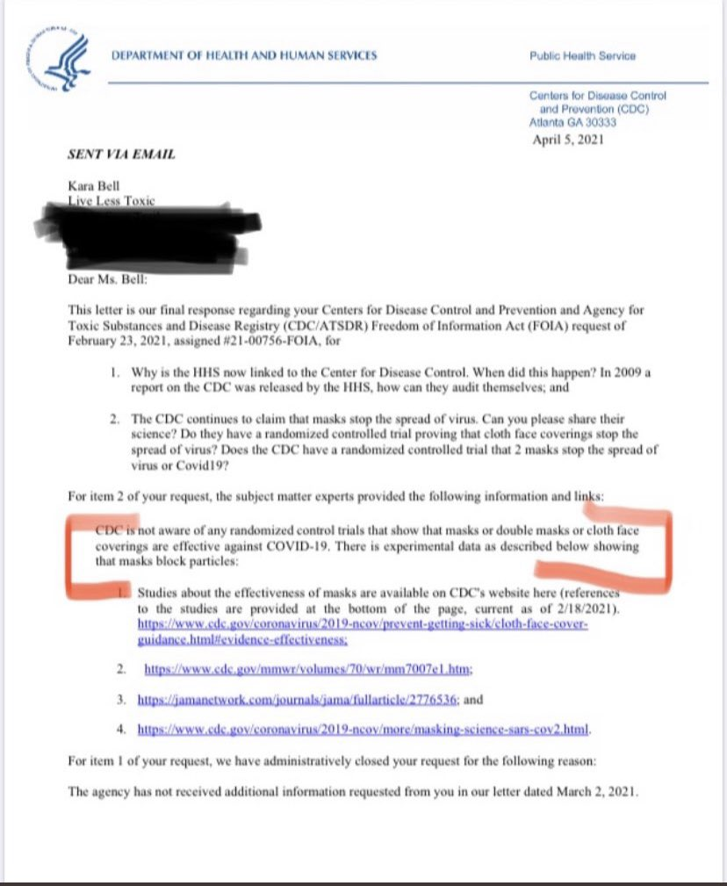

References to Natural Immunity Studies
Natural Immunity is lasting
(see MIT - https://technologyreview.com/2021/01/06/1015822/covid-19-immunity-likely-lasts-for-years/amp)
Natural Immunity effective against variants
(see PubMed - https://pubmed.ncbi.nlm.nih.gov/33427749/)
Vaccine harms to those diagnosed with COVID-19
(See Dr. Hooman Noorchashm - https://noorchashm.medium.com/a-letter-of-warning-to-fda-and-pfizer-on-the-immunological-danger-of-covid-19-vaccination-in-the-7d17d037982d)

References to Randomized Control Trial (RCT) Mask Induced Headache Studies
Headaches Associated With Personal Protective Equipment - A Cross-Sectional Study Among Frontline Healthcare Workers During COVID-19
(see PubMed - https://pubmed.ncbi.nlm.nih.gov/32232837/)
Headaches and the N95 face-mask amongst healthcare providers
(see PubMed - https://pubmed.ncbi.nlm.nih.gov/16441251/)

Reference to Asymptomatic Transmission Study
Post-lockdown SARS-CoV-2 nucleic acid screening in nearly ten million residents of Wuhan, China
(see nature.com - https://www.nature.com/articles/s41467-020-19802-w)

References for Risks to Children
Multisystem Inflammatory Syndrome (MIS-C):
Largely attributed to COVID-19
Child Population in SC ≈ 1,135,778 (Reference - https://www.infoplease.com/us/census/south-carolina/demographic-statistics)
50-99 cases reported (Reference - https://www.cdc.gov/mis-c/cases/index.html - Note: exact number of cases not disclosed)
Risk of a child contracting MIS-C in SC ≈ 0.00872% (or approximately 1 in 11,472)
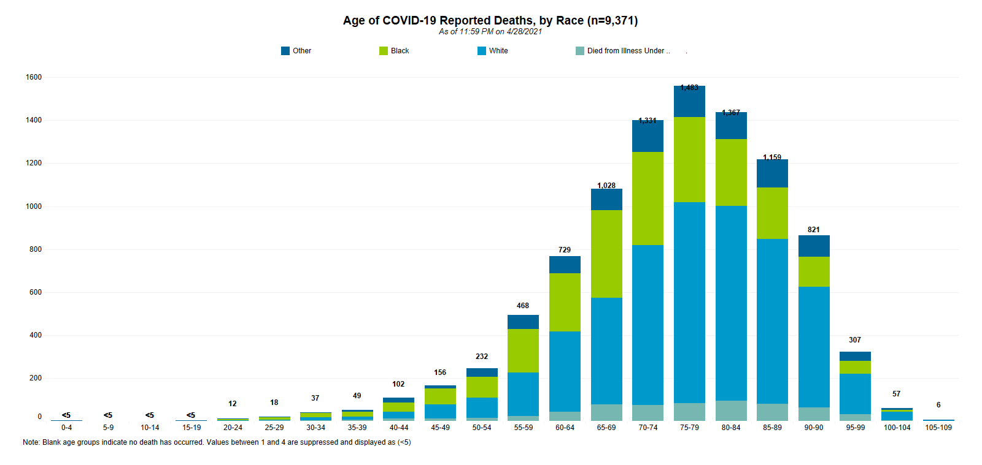
Source: https://scdhec.gov/sites/default/files/media/image/COVID19-Reported_Deaths_by_Race_Graphic-04_29_2021.png
Note: Blank age groups indicate no death has occurred. Values between 1 and 4 are suppressed and displayed as (<5) – What are they hiding? Why not report the actual values?
2-8 Deaths associated with COVID-19 (Under age 20) – Entire Pandemic
Range of Risk of a child dying from COVID-19 in SC ≈ 0.00018-0.0007% (or approx. 1 in 142,000-568,000)
Influenza (Flu):
3 Deaths associated with Flu (under age 18) – 2018 Season (Reference - https://scdhec.gov/sites/default/files/media/document/SC_2017-18_End_of_Season_Flu_Report.pdf)
Risk of a child dying from Flu in SC ≈ 0.00026% (or approximately 1 in 379,000)
Motor-Vehicle Fatalities:
Child population in US ≈ 70.4 Million (Reference - https://www.aecf.org/blog/us-child-population-grows-and-changes-74-million-kids-to-shape-future-of/#:~:text=U.S.%20Child%20Population%20Grows%20and,Casey%20Foundation)
1282 Deaths associated with Motor-Vehicle Accidents (under age 15) (Reference - https://injuryfacts.nsc.org/motor-vehicle/historical-fatality-trends/deaths-by-age-group/)
Risk of a child dying from Motor-Vehicle Accident in US ≈ 0.00182% (or approximately 1 in 55,000)
Acute Flaccid Myelitis (AFM):
This example was selected to illustrates the amount of error in health related predictions from the CDC.
238 cases in 2018 which they expected again in 2020 (Reference - https://thehill.com/policy/healthcare/510471-cdc-expects-2020-outbreak-of-rare-life-threatening-condition-affecting)
Risk of a child contracting this condition in US ≈ 0.00034% (or 1 in 296,000)
31 actual confirmed cases confirmed in 2020 by CDC (Reference - https://www.cdc.gov/acute-flaccid-myelitis/cases-in-us.html)

References to Hospitalization Rates vs. Stringency (including Mask Mandates)
There appears to be correlation of COVID Severity to State Stringency (including Mask Mandate) as can be seen in the data presented below.
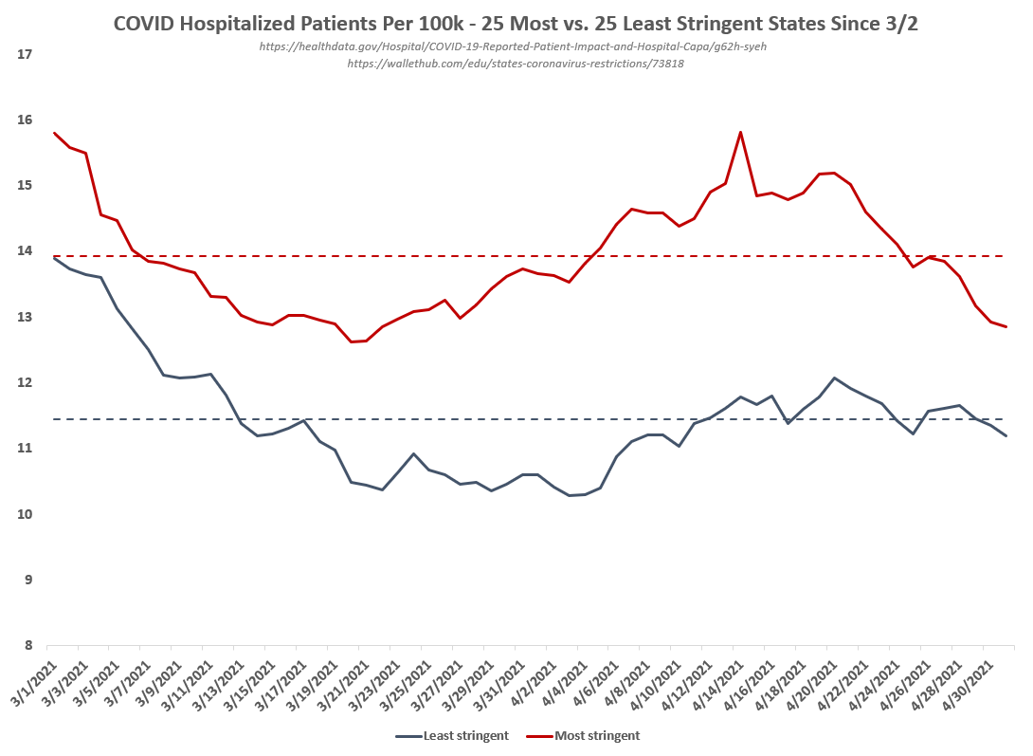
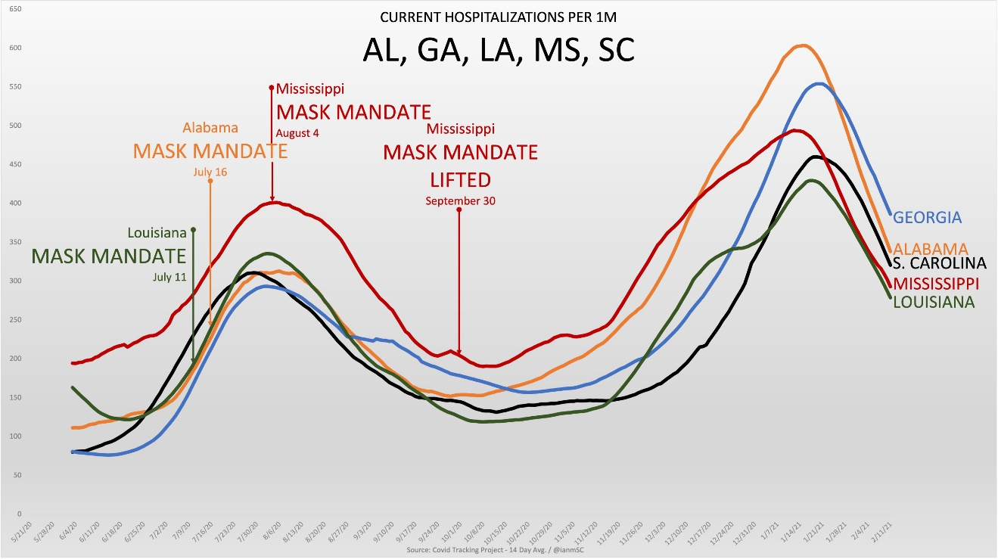

Research and References for Life Years Lost, Excess Deaths, and Life Expectancy
Background and Introduction:
Non-COVID Excess Deaths are a conglomerate of suicides, overdoses, deaths from alcoholism, & deaths due to a lack of treatment on life threatening conditions like cardiovascular disease and cancer. All a direct result of the Fear & Panic induced by the MSM & World Leadership!
Life Years Lost from COVID and from Excess Deaths (or deaths above average) is the best metric we have to illustrate the cost of life. Here's a chart I put together showing just the cost of life of Child Suicides vs COVID deaths for Lexington County. The comparison of Life Years Lost in Lexington will help put these tragic young deaths into context. It illustrates how a very small number of child deaths can exceed a much larger number of deaths closer to average age mortality. Please note that this chart is a bit older and does not account for Actuarial Life Expectancy (explained below). However, the illustration is still very valid.
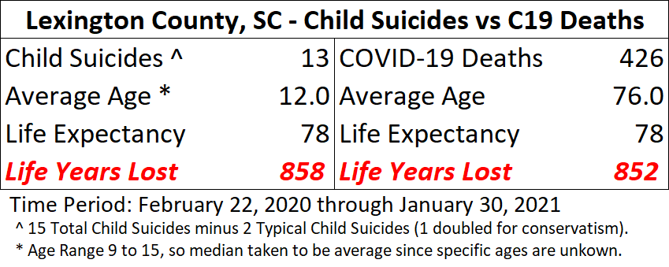
In my investigation of CDC data, I was able to determine the Average Age of Death from COVID. Also, because we now have 1 full year of data I was also able to back out the Average Age of Death from Non-COVID Excess Deaths by incorporating the 1.0 drop in Life Expectancy from 2019 to 2020. Using Actuarial Life Expectancy data, we see an increase in the numbers accordingly. Actuarial calculations are based on 2017 Actuarial Life Expectancy numbers (most recent available, not necessarily accurate, but applicable for estimation purposes). Extrapolation work is also included below for reference.
In the end, for the entire US over the past year, the Life Years Lost are staggering from not only COVID Deaths at 6.1 Million, but also from Non-COVID Excess Deaths, coming in at nearly 2.5 Million!
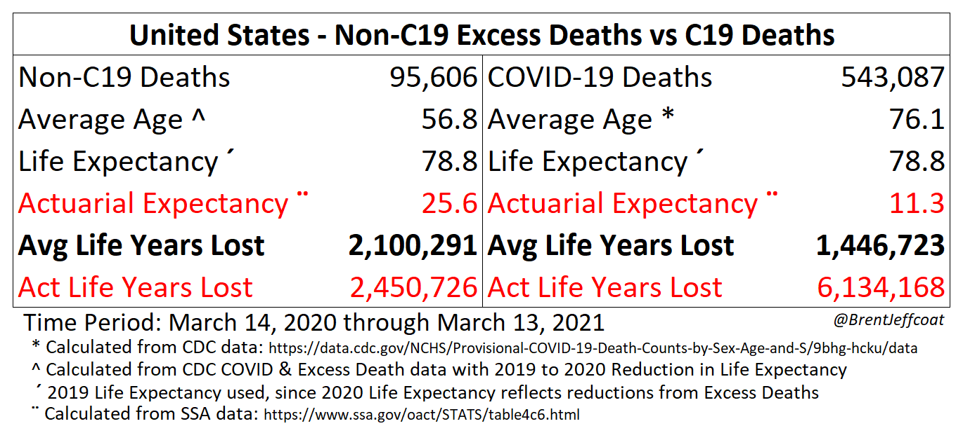
I realize that I’m no epidemiologist, public health official, or a medical doctor. However, I do have the gift of being able to analyze and interpret data sets. Specifically, I have the ability to apply my knowledge of statistical analysis to databases. If we truly take a scientific approach, we should be able to respectfully work together. It is, after all, about developing evidence based opinions.
In the end, it’s truly difficult to justify that we implemented the appropriate mitigations when the Life Years Lost for Non-COVID Excess Deaths are so substantial at 2.5 million!
I believe that the evidence presented herein makes a very clear and strong case for a Twin Pandemic: one natural, one imposed by our own hand, both catastrophic in nature.

Disclaimer:
All work shown here is my own, with references to CDC databases where the actual data was obtained. All opinions expressed herein represent mine and mine alone. I can provide more work in the form of an Excel Spreadsheet upon request. I can be reached via Twitter @BrentJeffcoat.
While Life Years Lost for both categories (COVID and Non-COVID Excess Deaths) increases using the Actuarial data, the resulting difference in COVID Life Years Lost is much larger. This takes reported COVID Death data at face value, which a point of contention amongst experts.
Life Years Lost with/from COVID is very significant, but many questions continue to surround how COVID Deaths are qualified. I've excluded adjustments in the data due to my own skepticism in this regard in order to present it as unbiased as possible & at face value.

Figures Illustrating My Findings:
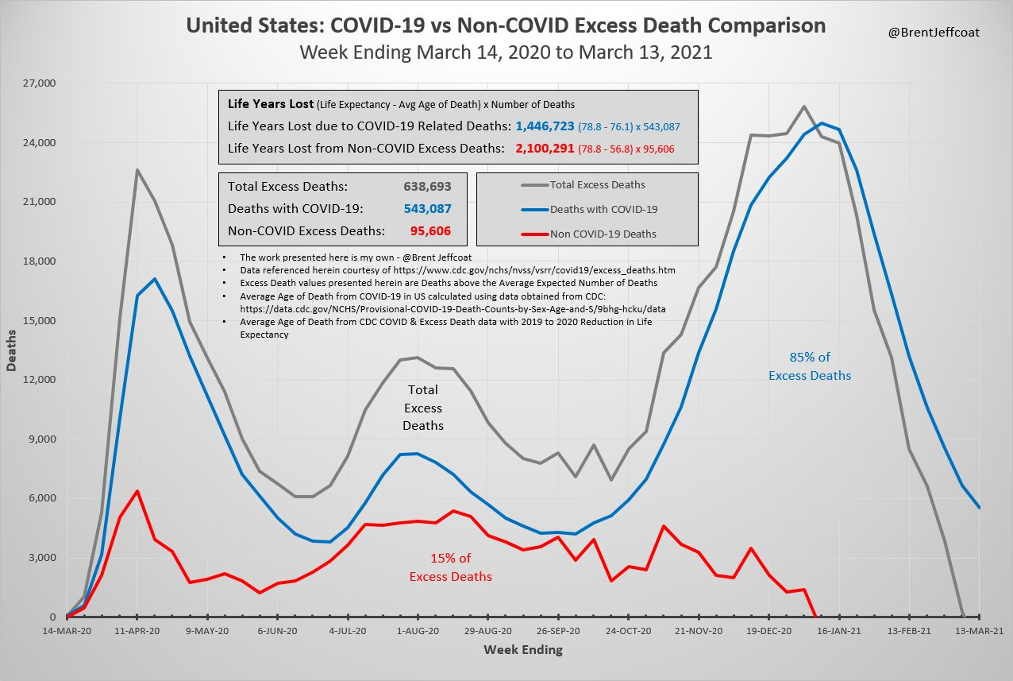
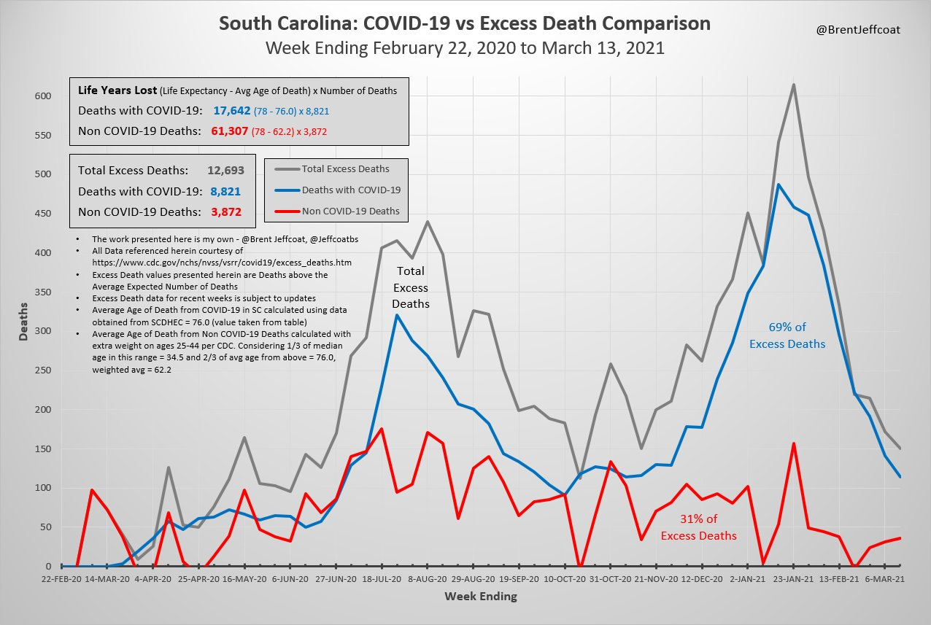

Supporting Calculation Tables:
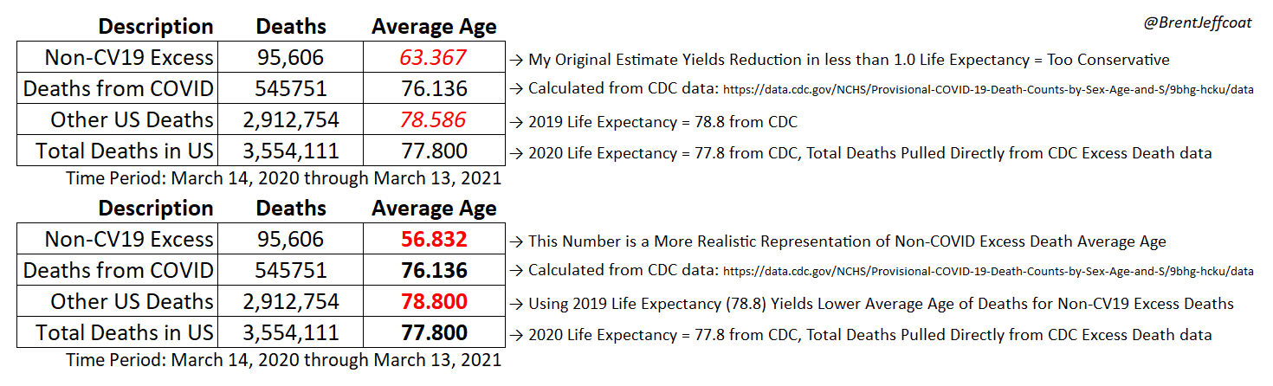
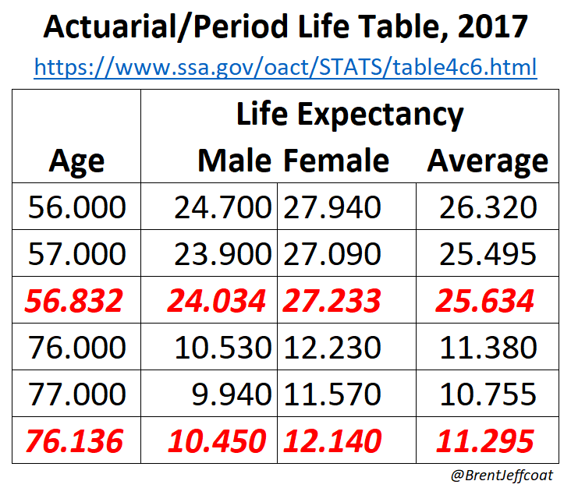

Research and References Regarding the Psychology of Conformity
The Psychology of Conformity:
https://academyofideas.com/2017/06/psychology-of-conformity/
Excerpt from “The Psychology of Conformity:
“Just like any religion, the religion of one’s society becomes easier to believe in, the grater the number of people to whom worship it. And this is why the nonconformists are so fears by the masses, the unique individuals plant seeds of doubt into the minds of the conformists regarding the significance of their social roles, and thus the significance of their very existence. Therefore, the masses actively discourage the cultivation of one’s uniqueness, and try and pressure them back to conformity – something they must do given that their existential significance is on the line.”
The 3 Phases of Conformity Described:
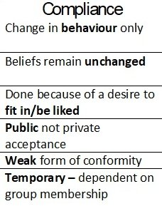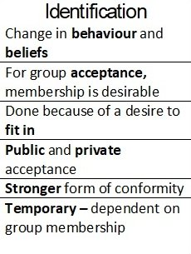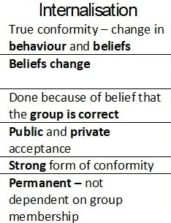
An Example of this New Religion:
Many who have “Internalized” this new way of thinking are devout followers of “The Science”, and therefore will not participate in society without following their new set of rules. Now, with the vaccine readily available, we find many of the zealots having strong emotional responses upon receiving “COVID-19 Vaccine” vaccinations. They are reduced to tears, and they document the event as if it were a ceremony of some sort. Theses zealots then return immediately to following all of the rules, even beyond two weeks of vaccination, as if the vaccination has done nothing to provide them with safety from the perceived deadly virus. This description can best be likened to the Baptismal ceremony in the Christian Church. It is not a means to an end, it is a symbol of one’s faith and only serves to enhance one’s practice in their religious beliefs.

